1 (a) set x_2 x_4 x_5 all to 0, then just solve the two equalities to get

-230; x_1 = 30, x_3 = 70.

(b) z = gives same result (NB assumed x_N = 0 so don’t need to consider the second part)

\Pi = ( -9 -7 )T

(c) r = ( 18 9 7 )T >= 0 so it’s optimal

(d)

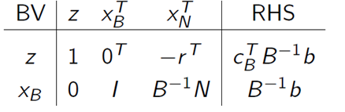

|  |  |  |  |  |  |  |
| --- | --- | --- | --- | --- | --- | --- |
|  | X_1 | X_3 | X_2 | X_4 | X_5 |  |
| Z |  |  | -18 | -9 | -7 | -230 |
| X_1 | 1 |  | 4 | 1 | 1 | 30 |
| X_3 |  | 1 | 8 | 3 | 2 | 70 |

2(a) <OUT OF SYLLABUS>

(b) TODO

3(a) let s_i be startup cost for product i; r_i be rev per unit

Max sum r_i x_i – s_i d_i over all i; (d_i is whether x_i >= 0, i.e. whether product i is invested in)

x_i <= M (k_i) and d_i = k_i for all i, k_i and d_i in {0, 1}, M is large int, can choose 10000.

sum of all x_i <= 10000

all x_i >= 0

(b)

Now we know d_i = 1 if project i taken. So simply

s_2 = 20000 + 20000 (1-d_1)

(c) Similarly

r_4 = 80 + 20(1-d_3)

(d)

d_3 + d_4 = 1

4 (a)

Consider the binary variable XY, , X = 1 if invest in new production facilities, Y = 1 if decide to improve product design

The payoff in the matrix is P = profit(A) – profit(B)

Example for A : 01; B : 00, P = 75 * 3 - 100 - 25*3 = 50

|  |  |  |  |  |
| --- | --- | --- | --- | --- |
|  | 00 | 01 | 10 | 11 |
| 00 | 0 | -50 | -25 | -100 |
| 01 | 50 | 0 | -50 | -125 |
| 10 | 25 | 50 | 0 | -25 |
| 11 | 100 | 125 | 25 | 0 |

(b)

-no dominated rows/cols

-no, show table with alpha and beta

-yes

-refer to notes